North Lincolnshire Council
Daily Event Analysis
19th December 2010

Overview
The Amvale Osiris measured a daily mean PM₁₀ concentration of 51µg/m³ on Sunday the 19th December 2010 exceeding the allowed 50µg/m³ as a daily mean. A check of the data has revealed that concentrations of PM₁₀ spiked between 11:00 & 13:00. During this period concentrations at the Amvale Osiris reached 702µg/m³. The nearby Redbourne TEOM measured a daily mean concentration of 27µg/m³ and the East Common Lane TEOM 28µg/m³. Other sites around Scunthorpe saw increases at this time including Low Santon and the Dawes Lane Coke Oven Osiris. Amvale was the standout result during this period.

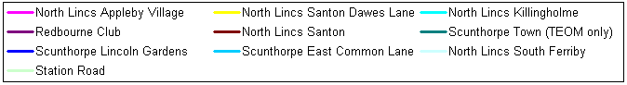

Met Conditions
Consistent NW winds were observed throughout the day. The wind between 11:00 & 13:00 ranged between 349° and 31°. Wind speeds averaged at 1.1 m/s. The highest wind speed was 1.6m/s in which the concentration of PM₁₀ reached 472µg/m³. No rain was measured throughout the day. Some snow covered the ground, a hard frost covered all exposed locations.

Episode Wind Range

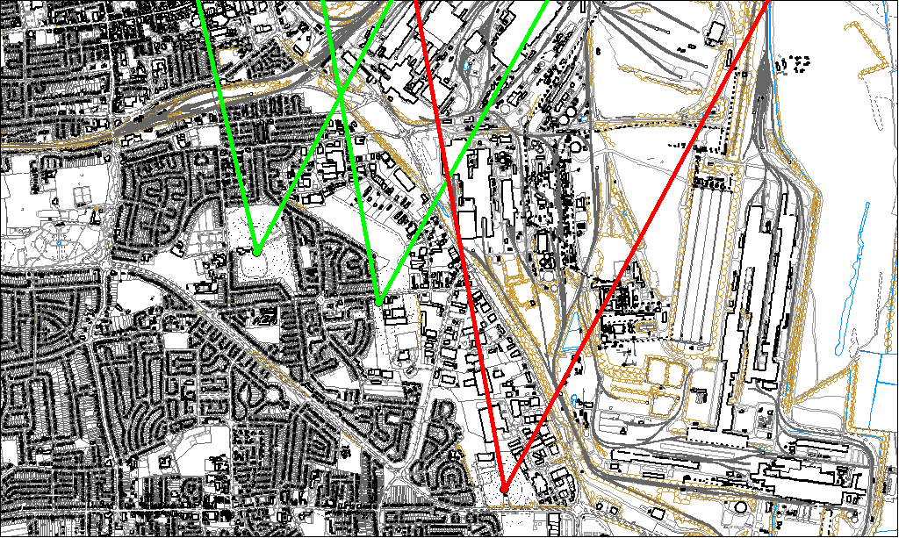

Potential Sources
The above map shows the Amvale Monitoring Station (indicated by the red lines) and the East Common Lane & Redbourne Sites (indicated by the green).

As the TEOMs were not subject to the same elevated levels as the Osiris, it is likely that the source of the episode did not originate from within the wind sectors relevant to the TEOMs (green lines). By removing the area of wind sectors affecting both the Osiris & TEOM we can identify specific areas on site that may have been responsible for the exceedance.

The likely areas include;

- Blast Furnaces
- Sinter Plant
- Intermediate Site
- Redbourn Site
- Appleby Coke Ovens

Others sites did demonstrate an increase in concentration at the same time as the Amvale Osiris spike. This is most likely because the 2hr period recorded the highest wind speeds of the day. The highest concentration of the period measured at 702µg/m³ occurred during 15 minutes in which the wind blew from 20°. 20° from the Amvale Osiris is the heart of the Blast Furnace operation.

